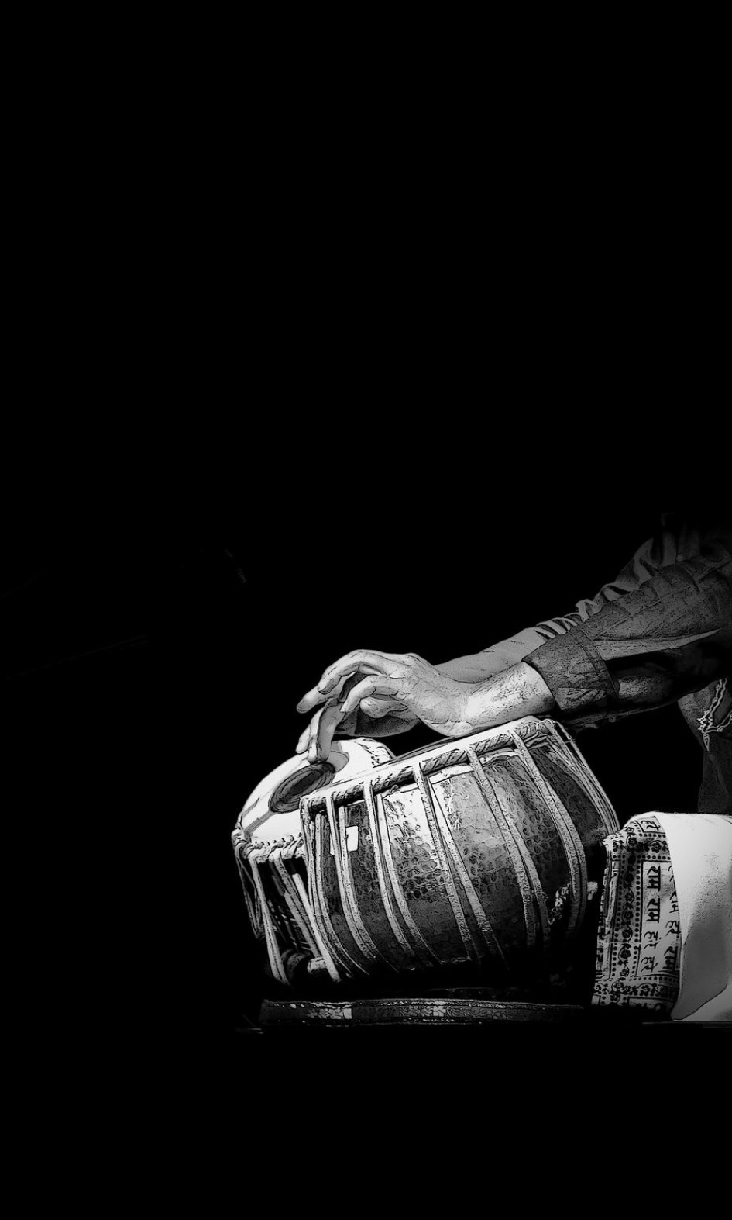 RABINDRA BHARATI UNIVERSITY

RBU ,B.T.ROAD,MAIN CAMPUS,KOLKATA



NAME : DEYA MUKHERJEE

COURSE : GEC-3.1

SUBJECT : PERCUSSION(TABLA)

Reg NO : 210543 of 2021-2022

Exam roll : Rab/nfas/210261

DEPT : VOCAL MUSIC

YEAR : 2022-2023

